LogmeOnce Encrypts Dropbox Files
LogmeOnce offers an easy way to add your own security to your files on Dropbox: Encrypt and password protect the entire Dropbox folder, or select individual files. Whether you are a Free or Paid Dropbox user, you can easily add more security layers with LogmeOnce;
- Encrypt Dropbox files & its content
- Use Advanced Encryption (AES-256)
- Designed for Consumers & Business with personal and business needs
- Free for all LogmeOnce backers , or LogmeOnce USB holders
No need to migrate or change anything! Continue to use your Dropbox just like before, except add security and YOU hold the encryption key, not anyone else. It’s as if, you are adding your own padlock to your storage space. And you have the key.

Before | After
  Example: Your files in  Dropbox are not encrypted  (Your file & its contact may be seen by anyone!) | 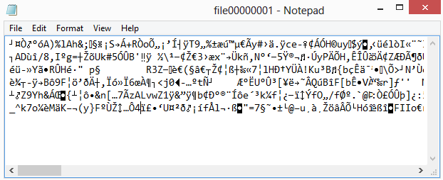  The same photo is encrypted;  LogmeOnce Protects your Dropbox files  (All files and their contents are encrypted)

LogmeOnce - Protecting Files in Cloud, PC, and USB
LogmeOnce is the perfect encryption solution for Dropbox, and other similar cloud storage services. Simply save your files (or drag & drop) into LogmeOnce. These files are automatically (On-the-fly) encrypted with AES-256 encryption.
Without taking away any of the advantages that Dropbox offers simply encrypt your files with LogmeOnce, and enjoy security without giving up comfort or ease of collaboration within Dropbox.
Recent security and privacy breaches concern everyone. Whether you save files on your computer, a USB flash drive, or on any cloud storage service such as Dropbox, LogmeOnce offers an easy way to protect your files, folders, photos and any documents. All of your files are encrypted individually and password protected.
How does your data can get compromised? It could be stolen/attached by a hacker on your PC or USB stick. Your files could be snatched during a Sync, upload or email to a 3rd party. Or, it can be at the destination in a cloud service, if hackers can get their hands on backend servers.
Here is how you can take security in your hands and do not leave it up to anybody to protect it for you. Conceptually, LogmeOnce works just like a bank safety deposit box. You can store important information and then lock it down (encrypt + Password protect) with encryption key that YOU and ONLY you have access to it. We make it easy to take the security of your data into your own hands.
LogmeOnce enables you to create an encrypted volume or folder on your computer or Dropbox. From now on, any time you save your files to this encrypted volume/folder, you files are automatically encrypted and password protected. Anyone trying to steal them, they get encrypt garbage as shown below

